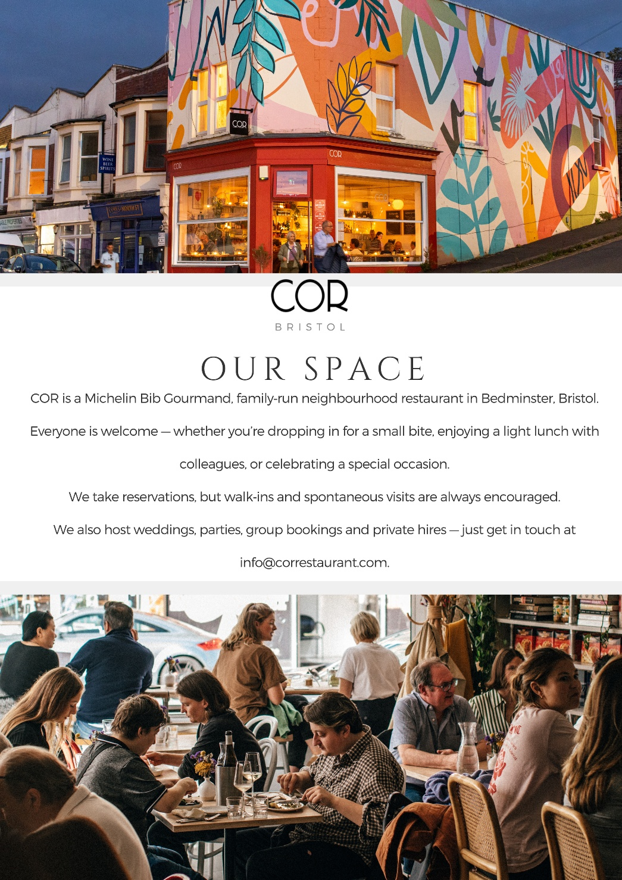
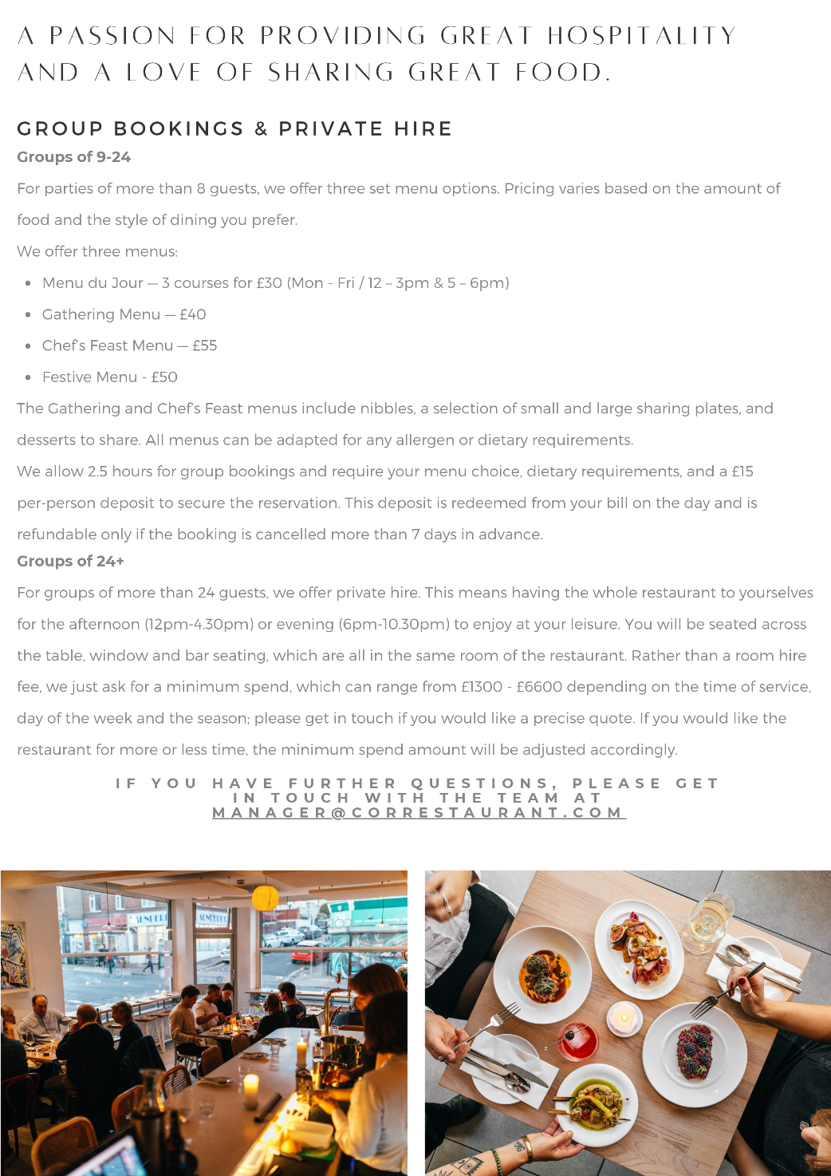

Menu du jour – 3 courses for £30. (Mon - Fri / 12 – 3pm & 5 – 6pm)

River Teign mussels, Asturian cider, agretti, lemon
or
Panisse, tomato ferment, Calabrian anchovy

-

Spinach and ricotta Malfati, slow cooked tomatoes & ricotta salata ᵛ
or
Salt marsh lamb shoulder, olive salsa verde, peroche, pistachio

-

Cheddar Valley strawberries, Italian meringue. toasted almond, balsamic ᵛ
or
Seasonal sorbet ᵛ

Menu du jour – 3 courses for £30. (Mon - Fri / 12 – 3pm & 5 – 6pm)

River Teign mussels, Asturian cider, agretti, lemon
or
Panisse, tomato ferment, Calabrian anchovy

-

Spinach and ricotta Malfati, slow cooked tomatoes & ricotta salata ᵛ
or
Salt marsh lamb shoulder, olive salsa verde, peroche, pistachio

-

Cheddar Valley strawberries, Italian meringue. toasted almond, balsamic ᵛ
or
Seasonal sorbet ᵛ

Gathering menu - £40

Bread & whipped black garlic butter ᵛ
Manzanilla olives
Salame Zia, caperberries
Payoya goat cheese, membrillo, crackers
Black fig, tahini, grape must, beurre noisette ᵛ
-
Roman style braised artichokes, Somerset mozzarella, gremolata ᵛ
Sorrento tomatoes, Jamón Serrano Reserva, migas
Scottish girolles in oloroso sherry on sourdough, yolk
Cannellini beans, lemon beurre blanc, smoked caviar, panko
Salt marsh lamb shoulder, leccino olive salsa verde, peroche, pistachio
-
Apricot sorbet
Tiramisu, orange, nutmeg, cocoa

Gathering menu - £40

Bread & whipped black garlic butter ᵛ
Manzanilla olives
Salame Zia, caperberries
Payoya goat cheese, membrillo, crackers
Black fig, tahini, grape must, beurre noisette ᵛ
-
Roman style braised artichokes, Somerset mozzarella, gremolata ᵛ
Sorrento tomatoes, Jamón Serrano Reserva, migas
Scottish girolles in oloroso sherry on sourdough, yolk
Cannellini beans, lemon beurre blanc, smoked caviar, panko
Salt marsh lamb shoulder, leccino olive salsa verde, peroche, pistachio
-
Apricot sorbet
Tiramisu, orange, nutmeg, cocoa

Festive - £50

Savoury canelé, goats cheese, beetroot & thyme ᵛ
-
Bread & whipped black garlic butter ᵛ
Burrata from Puglia, grape must, pistachio ᵛ
-
Hand dived Devon scallop, blood orange, beurre noisette, capers
Cannellini beans, lemon beurre blanc, smoked caviar, panko
-
Hereford beef onglet cooked over fire, sweet onion, radicchio, red wine jus
Cornish potatoes, cafe de paris butter
-
Baron bigod, membrillo, grapes, crackers
-
Tiramisu, orange, nutmeg, cocoa ᵛ

Festive - £50

Savoury canelé, goats cheese, beetroot & thyme ᵛ
-
Bread & whipped black garlic butter ᵛ
Burrata from Puglia, grape must, pistachio ᵛ
-
Hand dived Devon scallop, blood orange, beurre noisette, capers
Cannellini beans, lemon beurre blanc, smoked caviar, panko
-
Hereford beef onglet cooked over fire, sweet onion, radicchio, red wine jus
Cornish potatoes, cafe de paris butter
-
Baron bigod, membrillo, grapes, crackers
-
Tiramisu, orange, nutmeg, cocoa ᵛ

Chef Feast Menu - £55

Savoury canelé, beetroot, goats cheese & thyme ᵛ
-
Bread & whipped black garlic butter ᵛ
Black fig, tahini, grape must, beurre noisette ᵛ
Roman style braised artichokes, Somerset mozzarella, gremolata ᵛ
-
Sorrento tomatoes, Jamón Serrano Reserva, migas
Cannellini beans, lemon beurre blanc, smoked caviar, panko
Salt marsh lamb shoulder, leccino olive salsa verde, peroche, pistachio
-
Spinach & sheeps ricotta malfati, slow cooked tomatoes, ricotta salata
Whole Cornish plaice cooked over fire, romesco sauce, alioli, frites
Grilled Hereford onglet, cafe de paris butter, red wine jus
-
Grilled little gem lettuce, crème fraîche, soft herbs ᵛ
-
Tiramisu, orange, nutmeg, cocoa ᵛ

Chef Feast Menu - £55

Savoury canelé, beetroot, goats cheese & thyme ᵛ
-
Bread & whipped black garlic butter ᵛ
Black fig, tahini, grape must, beurre noisette ᵛ
Roman style braised artichokes, Somerset mozzarella, gremolata ᵛ
-
Sorrento tomatoes, Jamón Serrano Reserva, migas
Cannellini beans, lemon beurre blanc, smoked caviar, panko
Salt marsh lamb shoulder, leccino olive salsa verde, peroche, pistachio
-
Spinach & sheeps ricotta malfati, slow cooked tomatoes, ricotta salata
Whole Cornish plaice cooked over fire, romesco sauce, alioli, frites
Grilled Hereford onglet, cafe de paris butter, red wine jus
-
Grilled little gem lettuce, crème fraîche, soft herbs ᵛ
-
Tiramisu, orange, nutmeg, cocoa ᵛ

